|  |  |  |  |
| --- | --- | --- | --- |
| **Course Name:** | **ACS** | **Semester:** | **V** |
| **Date of**  **Performance:** | **31/07/24** | **Batch No:** | **B1** |
| **Faculty Name:** | **Prof. Shila Dande** | **Roll No:** | **16014022050** |
| **Faculty Sign & Date:** |  | **Grade / Marks:** | **___ / 25** |

Experiment No: 2

Title: Determine the transfer function for given closed loop system in block diagram representation.

**Determine the transfer function for given closed loop system in block diagram representation.**

**Aim and Objective of the Experiment:**

CO1:

**COs to be achieved:**

The closed-loop systems are designed to automatically achieve and maintain the desired output condition by comparing it with the actual condition. It does this by generating an error signal which is the difference between the output and the reference input. In other words, a “closed-loop system” is a fully automatic control system in which its control action being dependent on the output in some way.

The **Transfer Function** of any electrical or electronic control system is the mathematical relationship between the systems input and its output, and hence describes the behavior of the system. Note also that the ratio of the output of a particular device to its input represents its gain. Then we can correctly say that the output is always the transfer function of the system times the input. Consider the closed-loop system below.

A **Closed-loop Control System**, also known as a feedback control system is a control system which uses the concept of an open loop system as its forward path but has one or more feedback loops (hence its name) or paths between its output and its input. The reference to “feedback”, simply means that some portion of the output is returned “back” to the input to form part of the systems excitation.

**Theory:**

|  |
| --- |
|  |
| **Procedure :** |
| 1. First put numerator coefficients for first transfer function. 2. Then put denominator coefficients for first transfer function. 3. First put numerator coefficients for second transfer function. 4. Then put denominator coefficients for second transfer function. 5. Select the connection type ( cascade, parallel, feedback ). 6. Calculate overall transfer function according to connection of different elements ( sub systems). |

Virtual Lab Simulation Result :

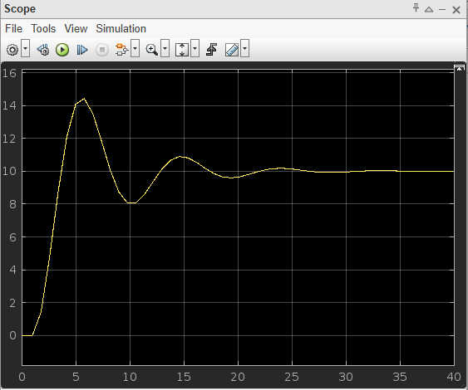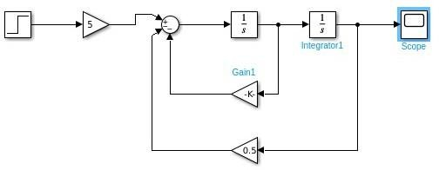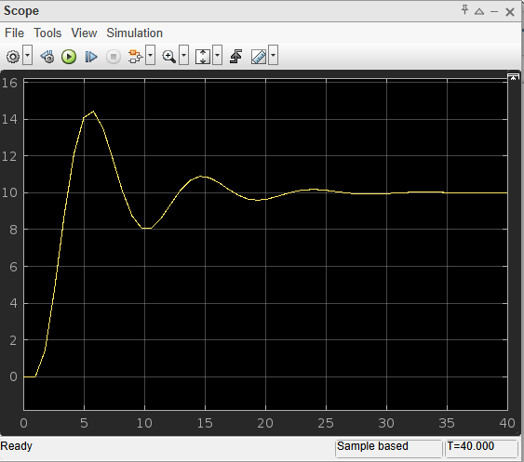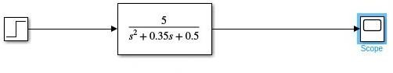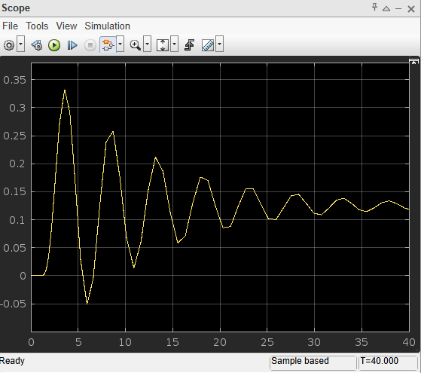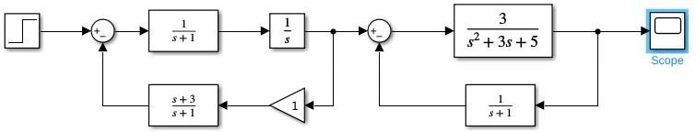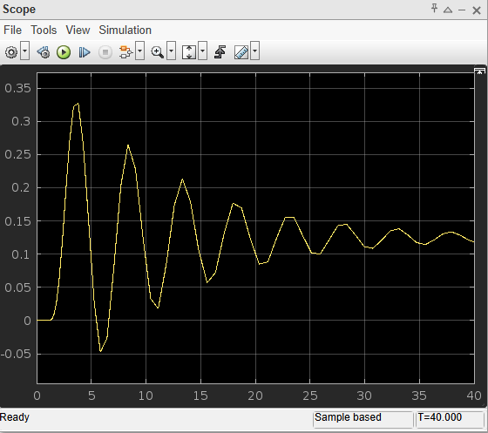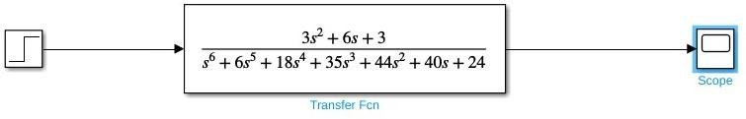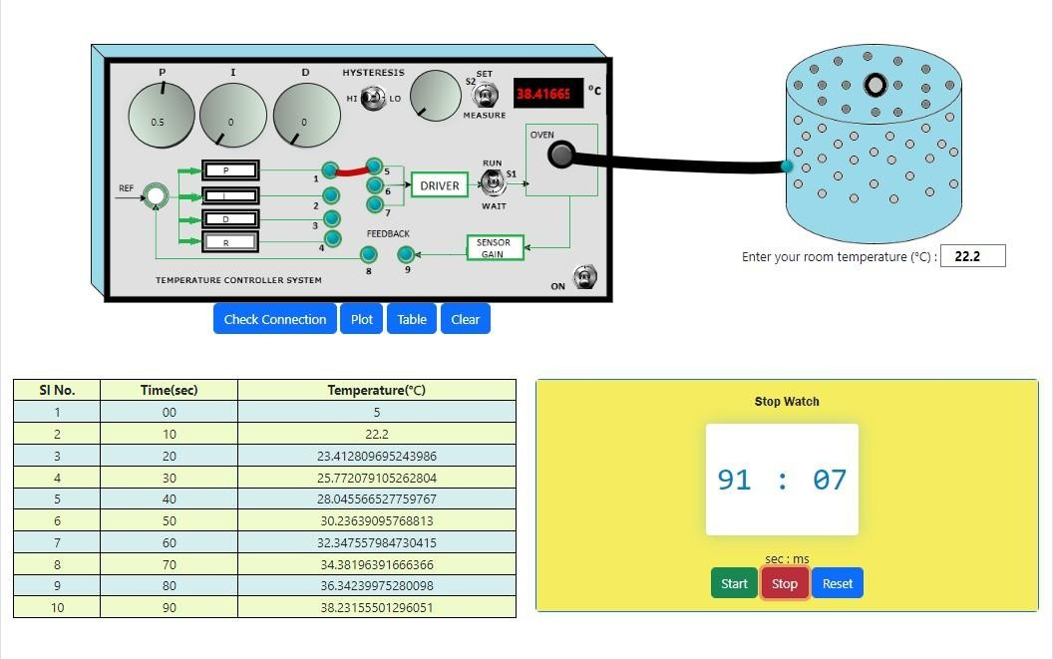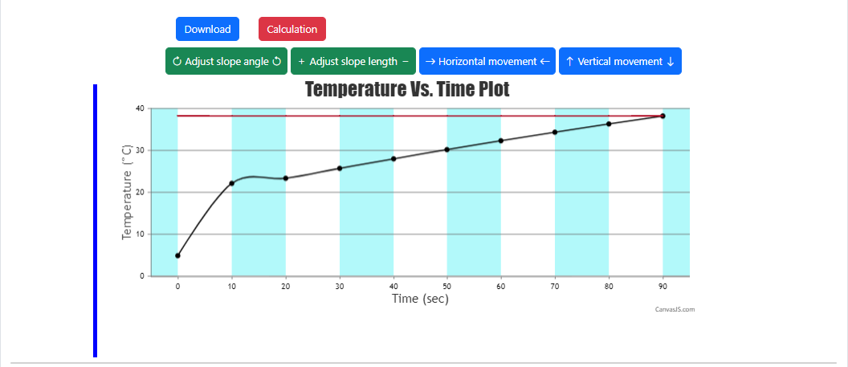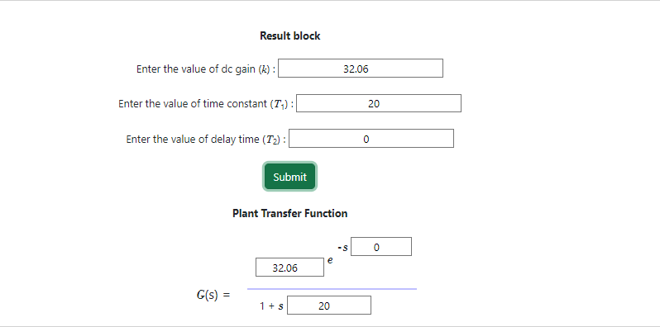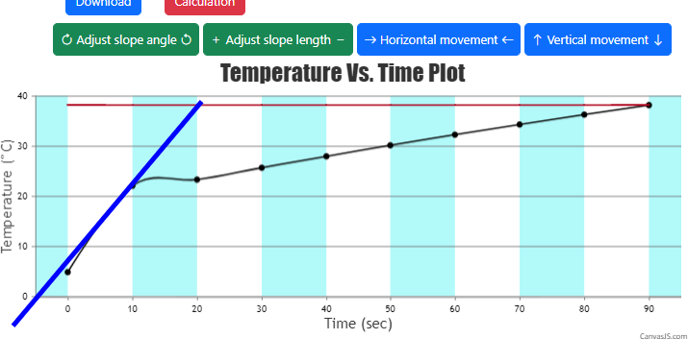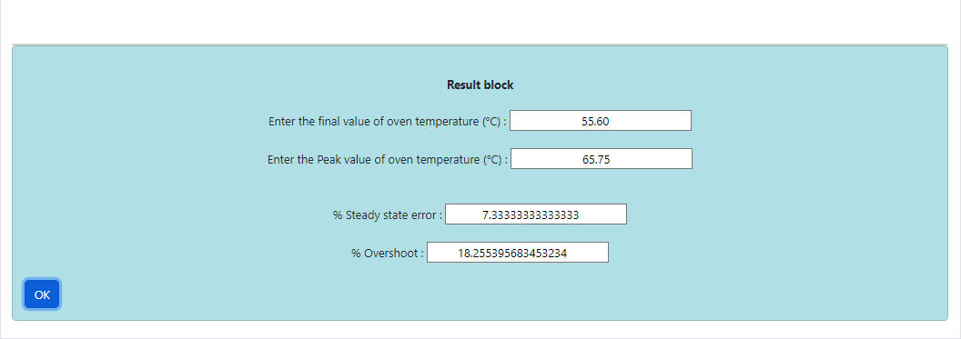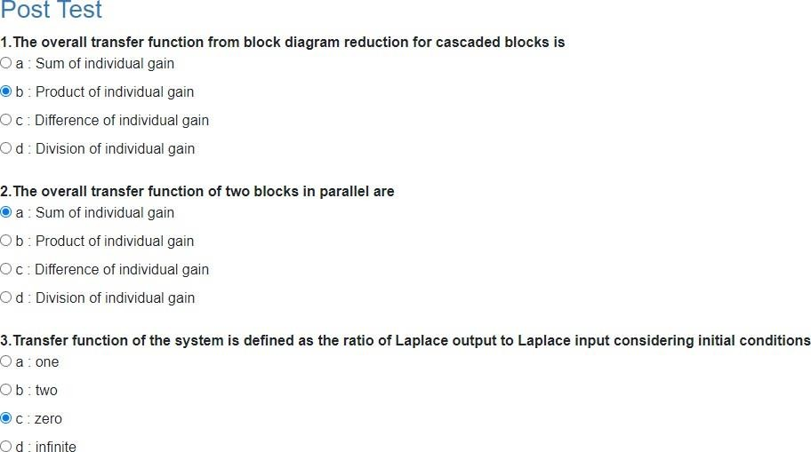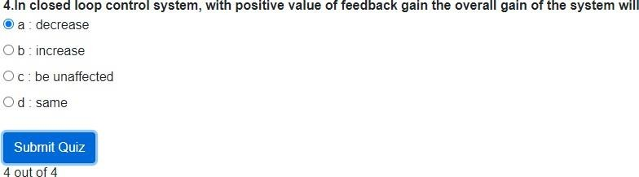

**3.A good control system has all the following features except**

d : none

c : open loop system

**b : closed loop system**

a : semi - closed loop system of these

**2.A control system in which the control action is somehow dependent on the output is known as**

d : is feedback control system

output

**c : only system parameters have effect on the control**

b : output is dependent on control input

**1.In an open loop control system**

a : output is independent of control input

**Post Lab Objective type Questions:**

a : good stability **b : slow response** c : good accuracy d : sufficient power handling capacity



1. **At summing point, more than one signal can be**

a : Added b : Subtracted c : Multiplied **d : Both a and b**

1. **The overall transfer function from block diagram reduction for cascaded blocks is**

a : Sum of individual gain **b : Product of individual gain** c : Difference of individual gain d : Division of individual gain

1. **The overall transfer function of two blocks in parallel are**

**a : Sum of individual gain** b : Product of individual gain c : Difference of individual gain d : Division of individual gain

1. **Transfer function of the system is defined as the ratio of Laplace output to Laplace input considering initial conditions**

a : one b : two **c : zero** d : infinite

1. **In closed loop control system, with positive value of feedback gain the overall gain of the system will**

**a : decrease** b : increase c : be unaffected d : same

**By performing this experiment , I understood that in a closed-loop control system, feedback ensures automatic adjustment to maintain desired output by comparing it with actual conditions. The system generates an error signal based on this comparison, and the transfer function quantifies the system's response. This approach provides precise, self-correcting control by integrating output-dependent adjustments.**

**Conclusion:**

Signature of faculty in-charge with Date: